In this problem, a tree is an **undirected graph** that is connected and has no cycles.

You are given a graph that started as a tree with n nodes labeled from 1 to n, with one additional edge added. The added edge has two **different** vertices chosen from 1 to n, and was not an edge that already existed. The graph is represented as an array edges of length n where edges[i] = [ai, bi] indicates that there is an edge between nodes ai and bi in the graph.

Return *an edge that can be removed so that the resulting graph is a tree of* n *nodes*. If there are multiple answers, return the answer that occurs last in the input.

**Example 1:**

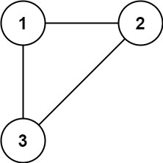

Input: edges = [[1,2],[1,3],[2,3]]  
Output: [2,3]

**Example 2:**

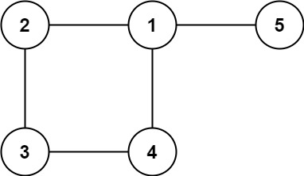

Input: edges = [[1,2],[2,3],[3,4],[1,4],[1,5]]  
Output: [1,4]

**Constraints:**

* n == edges.length
* 3 <= n <= 1000
* edges[i].length == 2
* 1 <= ai < bi <= edges.length
* ai != bi
* There are no repeated edges.
* The given graph is connected.